**Classroom Activity: How to create a MongoDB Cloud Atlas account & create a database in Atlas.​**

Step 1: Visit MongoDB Atlas Website:

* Go to [MongoDB Atlas](https://www.mongodb.com/cloud/atlas).

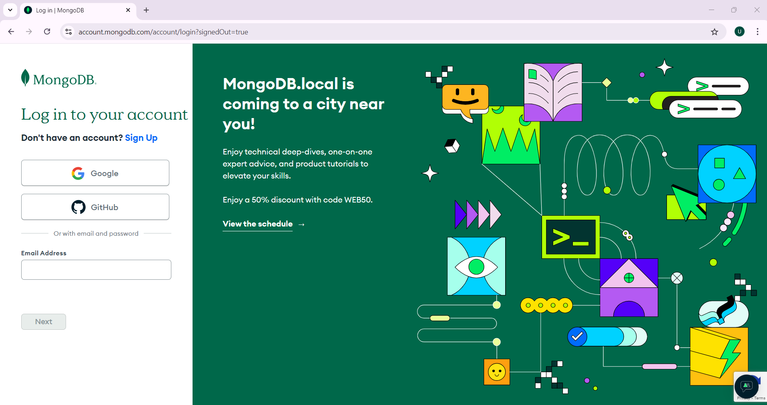

Step 2: Sign Up:

* Click on the "Start Free" button.
* You can sign up using your Google account, GitHub account, or by providing an email and password.

Step 3: Verify Email:

* If you signed up with an email, you'll receive a verification email. Click on the verification link to activate your account.

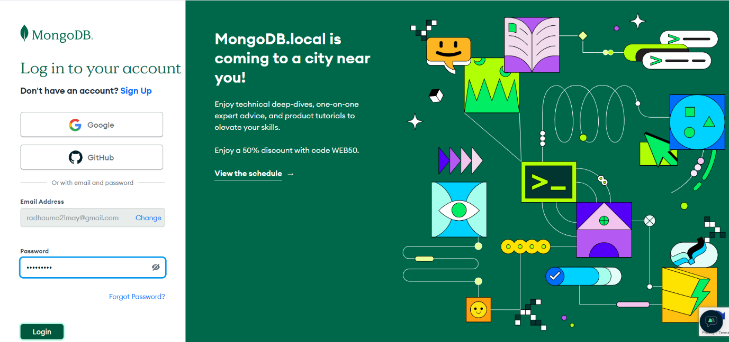

Step 4: Create a New Cluster

Once logged in, you’ll see a "Build a Cluster" button on the dashboard. Click on it.

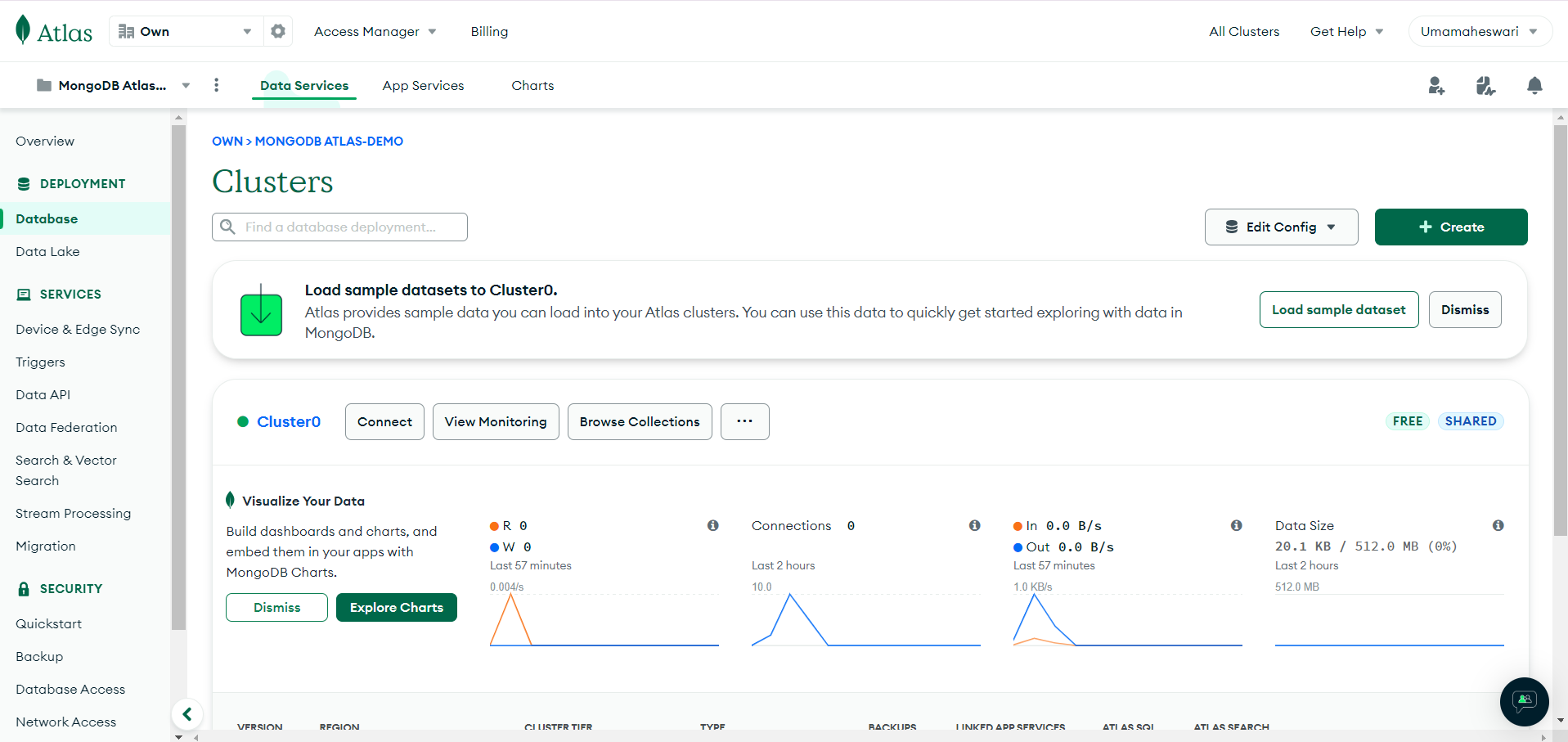

Step 5: Choose a Cloud Provider and Region

* Select a cloud provider (AWS, Google Cloud, Azure).
* Choose a region close to your location for better performance.
* For a free tier, choose the "M0 Sandbox" (Free forever). It offers limited resources but is sufficient for learning and small projects.
* You can keep the default name or provide a custom name for your cluster.

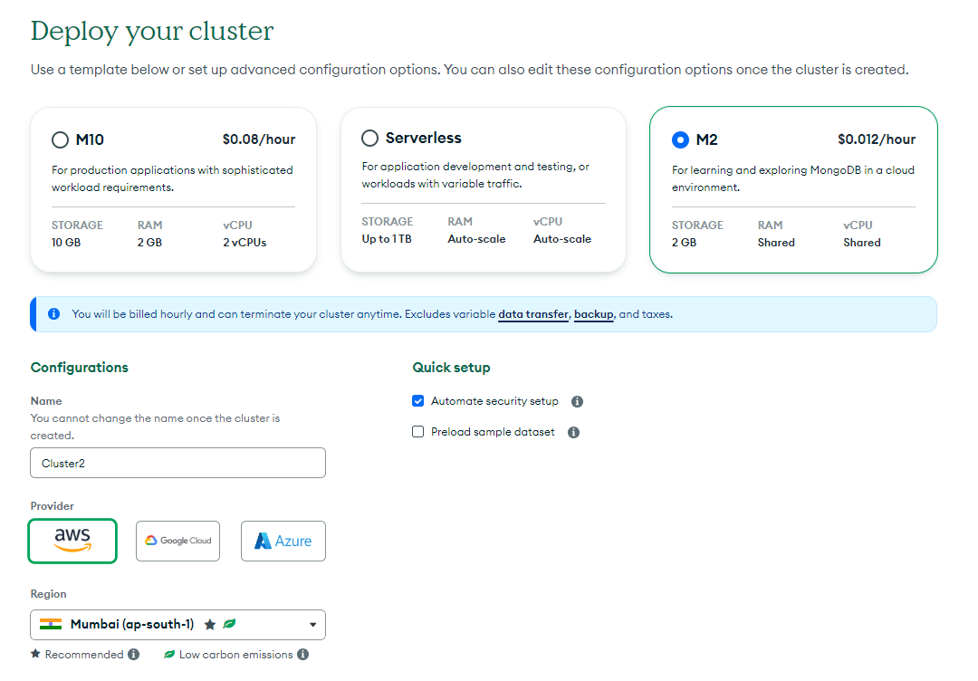

* Click on "Create Cluster." The cluster provisioning might take a few minutes

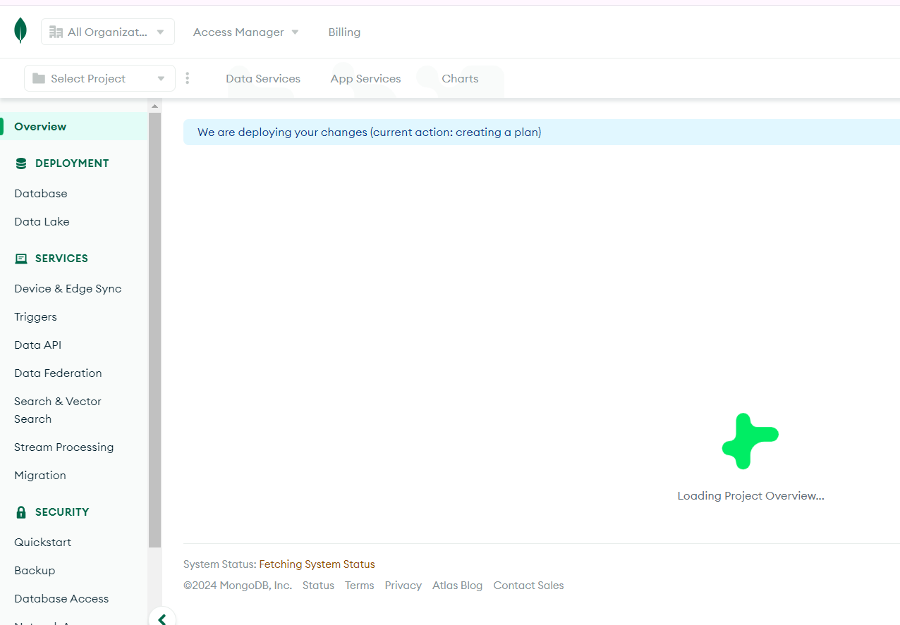



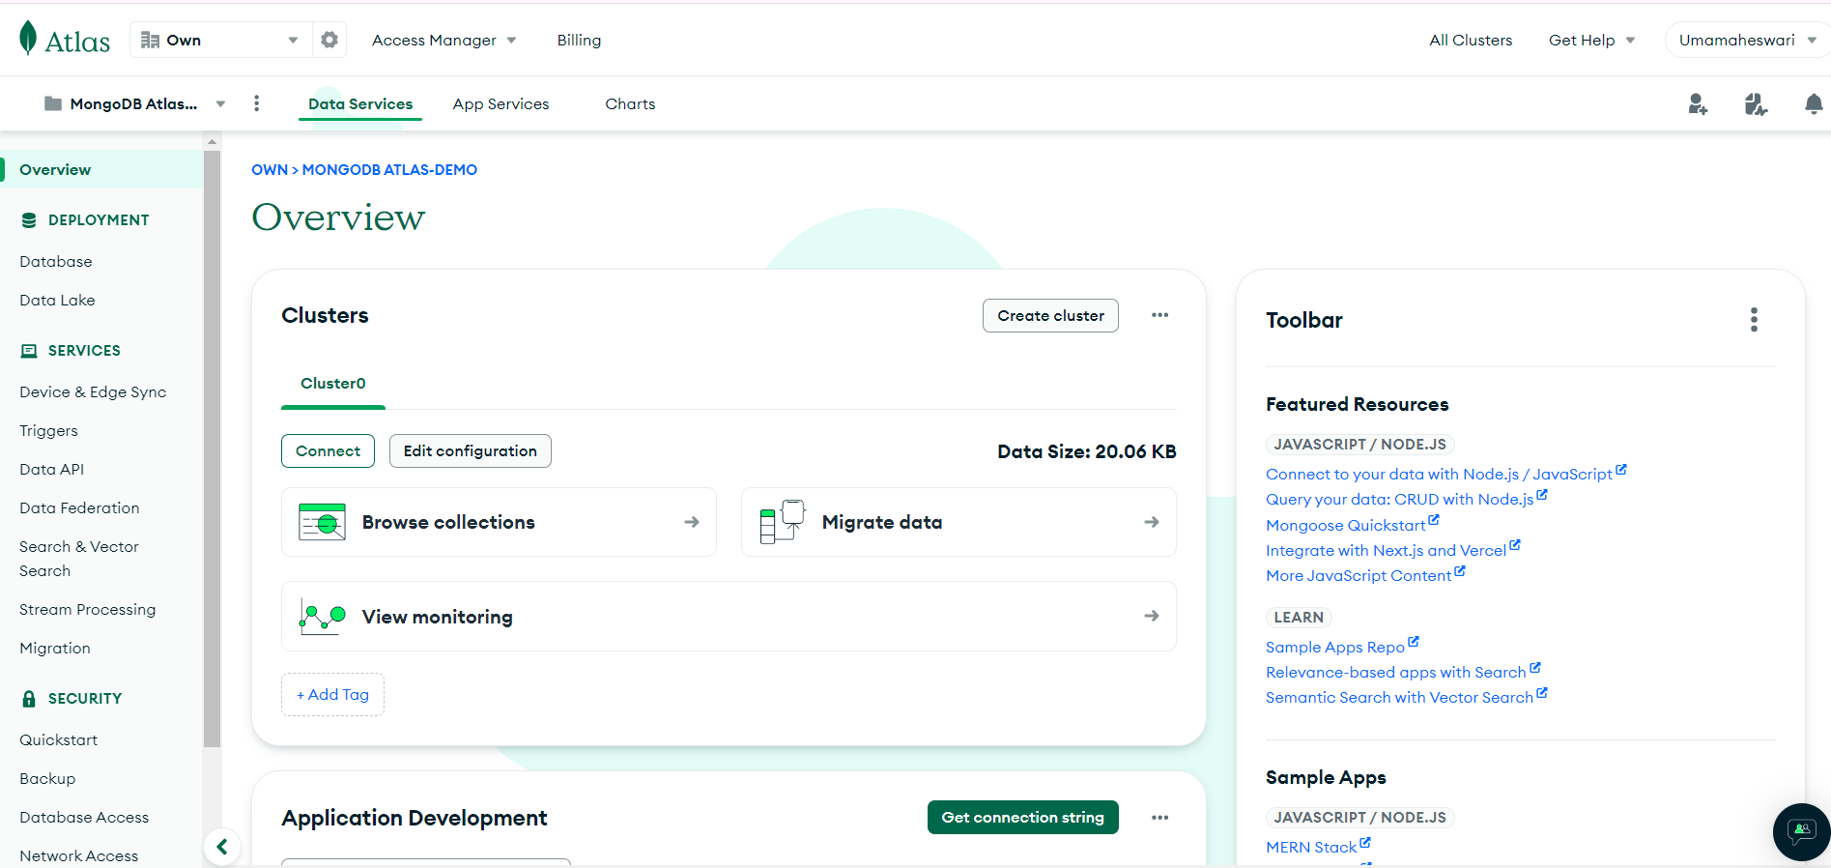

Step 6: Create a Database and Collection

* Once your cluster is created, click on the "Collections" tab within your cluster.
* Click on "Add My Own Data."

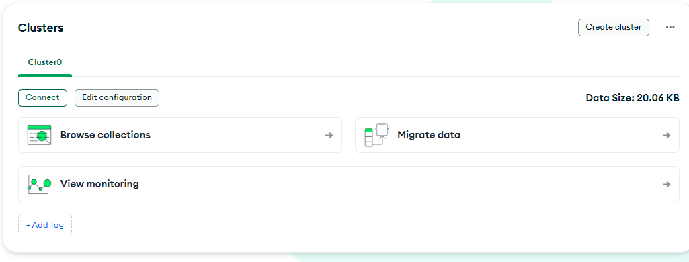

* Provide a name for your database.

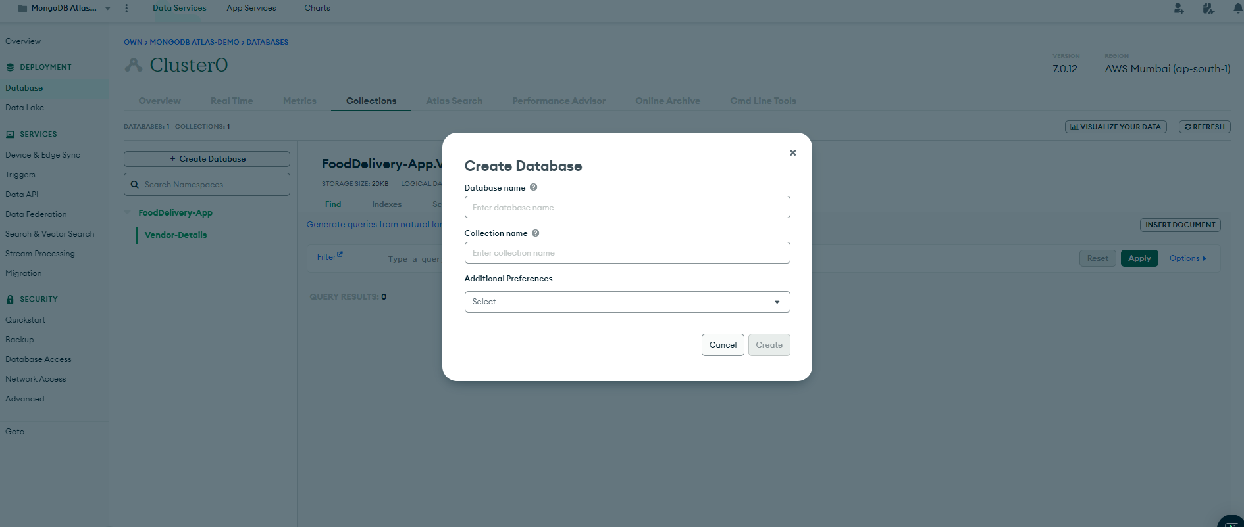

* Provide a name for the collection (equivalent to a table in relational databases).

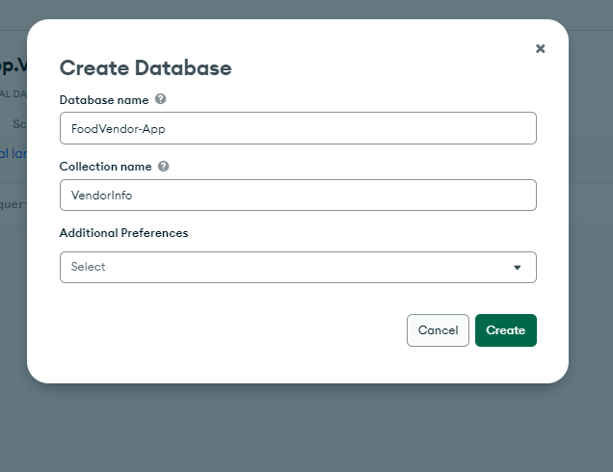

* Click on "Create" to set up your database and initial collection.

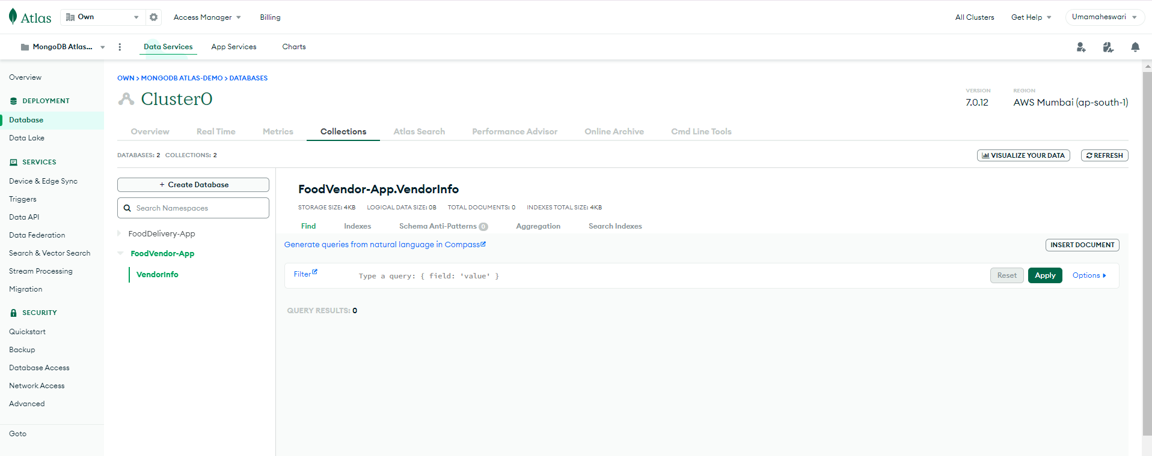

* Insert add into the Database

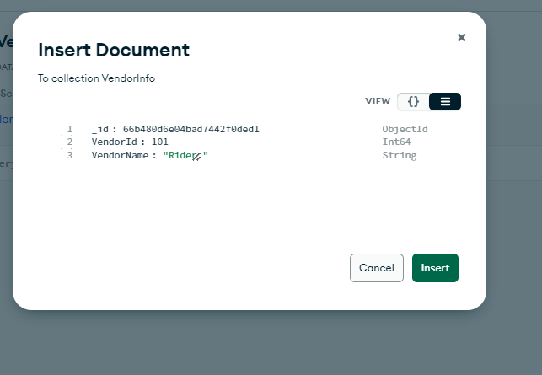

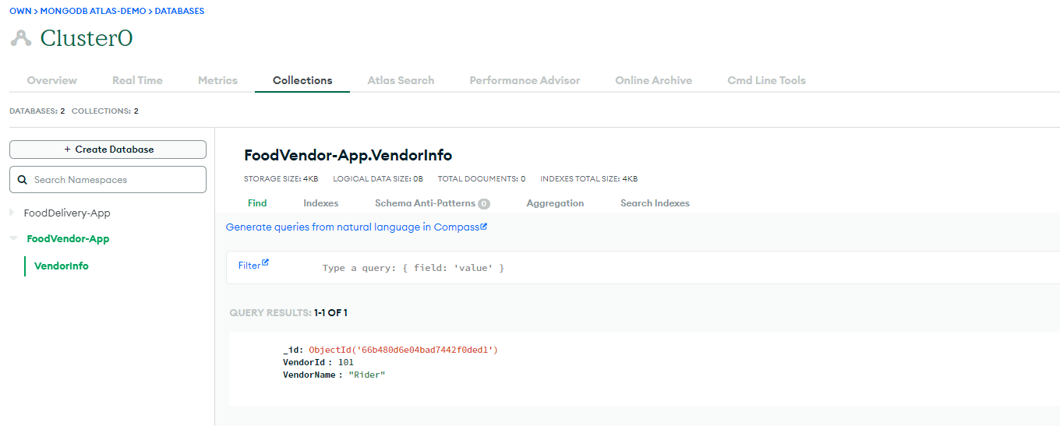

Step 7: Connect to Your Database

* Go back to your cluster and click on the "Connect" button.
* Choose a connection method. For most cases, "Connect Your Application" is the most suitable.
* Select your driver and version (e.g., Node.js, Python).
* Copy the connection string provided.

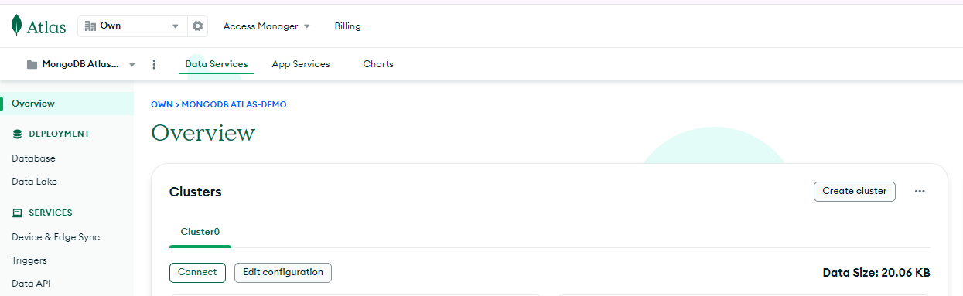

Step 8: Modify Connection String:

* Replace <username> and <password> with the database user credentials you created.
* Replace <dbname> with the name of your database.

